Local Housing Trust Fund Basics

1. What is a Local Housing Trust Fund (LHTF)?

A Local Housing Trust Fund is similar to a savings account that can receive money from different sources and to spend on local housing needs. The LHTF spends money according to its Program Guidelines.

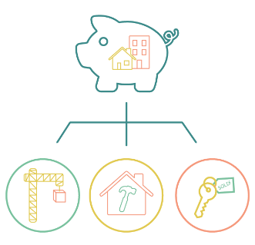



1. How are the Program Guidelines Determined?

Program Guidelines are the rules by which a LHTF can spend money. Guidelines can be established in two ways: by the organization that is providing money to the Fund or through a community input process.

1. What are “Round 1” and “Round 2” Funds?

“Round 1” refers to funds that the State of California granted to the LHTF. These funds must be spent on housing projects that meet the following Program Guidelines criteria: new construction, rental, multifamily, and affordable to people with low or very low income.

“Round 2” refers to future funds that the City of Fresno will provide to the LHTF. In 2023, City staff will work with community members to create the Program Guidelines for Round 2 funding.

1. How can the Community shape the Local Housing Trust Fund?

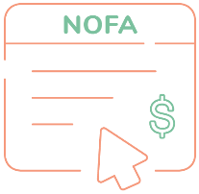Round 1 will have a Notice of Funding Availability (NOFA) where housing projects will apply to receive money from the LHTF. Community members are invited to rank priorities for how the applications will be scored.

**APPLY**



In Round 2, community members will be able to co-create the Program Guidelines to determine how the LHTF will spend its future funding.

Stay up to date! Visit [www.fresno.gov/LHTF](http://www.fresno.gov/LHTF)